Name of the Student: Polla Vishnu Vardhan, Vivek Goud Adula, Myadarapu Navya | Academic Year: 2025-26
Student Registration Number: 231U1R2002, 231U1R2015, 231U1R2024 | Year & Term: III - III
Study Level: B-Tech | Class & Section: AIML- III – A
Name of the Course: Natural Language Processing | Name of the Instructor: Mr. K. Ravikanth
Name of the Assessment: Project Design | Date of Submission: 09-03-2026

PROJECT DESIGN
LEARNING GROUP - 5
TITLE OF THE PROJECT: REAL-TIME FAKE JOB OFFER DETECTION USING NATURAL LANGUAGE PROCESSING AND BROWSER EXTENSION INTEGRATION
PROJECT DOMAIN: NATURAL LANGUAGE PROCESSING
INDEX
SNO. | CONTENT | PAGE NO.
1. | Abstract | 2
2. | Diagrams | 3
3. | Software requirements | 5
4. | Functional requirements | 5
5. | Non-Functional Requirements | 9
6. | Test Case | 11

TITLE OF THE PROJECT
REAL-TIME FAKE JOB OFFER DETECTION USING NATURAL LANGUAGE PROCESSING AND BROWSER EXTENSION INTEGRATION
- ABSTRACT:
The increasing dependence on digital platforms for job searching has led to a significant rise in recruitment-related fraud. Fake job offers distributed through email services, professional networking platforms, and online job portals often deceive job seekers by demanding registration fees, processing charges, or sensitive personal information. Many users, particularly fresh graduates and unemployed youth, struggle to distinguish between legitimate opportunities and fraudulent recruitment messages due to the realistic language used by scammers.
To address this issue, this project proposes a real-time fake job detection system based on Natural Language Processing integrated within a browser extension environment. The system automatically analyzes job-related textual content from platforms such as Gmail, LinkedIn, and jobs portals, and predicts the likelihood of fraudulent intent using machine learning-based text classification techniques.
Text preprocessing techniques including tokenization, text normalization, stop-word removal, and vectorization are applied to prepare the data for modeling. A baseline classifier using traditional machine learning algorithms such as Logistic Regression or SVM is developed for comparison, followed by a transformer-based model for improved contextual understanding.
The proposed solution provides a practical, deployable, and real-time fraud detection framework that enhances online safety for job seekers by identifying deceptive recruitment messages before users take financial or personal risks.
Keywords: Fake Job Detection, Recruitment Scam, Natural Language Processing, Text Classification, Machine Learning, BERT, Browser Extension, Real-Time Detection, Fraud Prevention
- DIAGRAMS:
  - ARCHITECTURE DIAGRAM
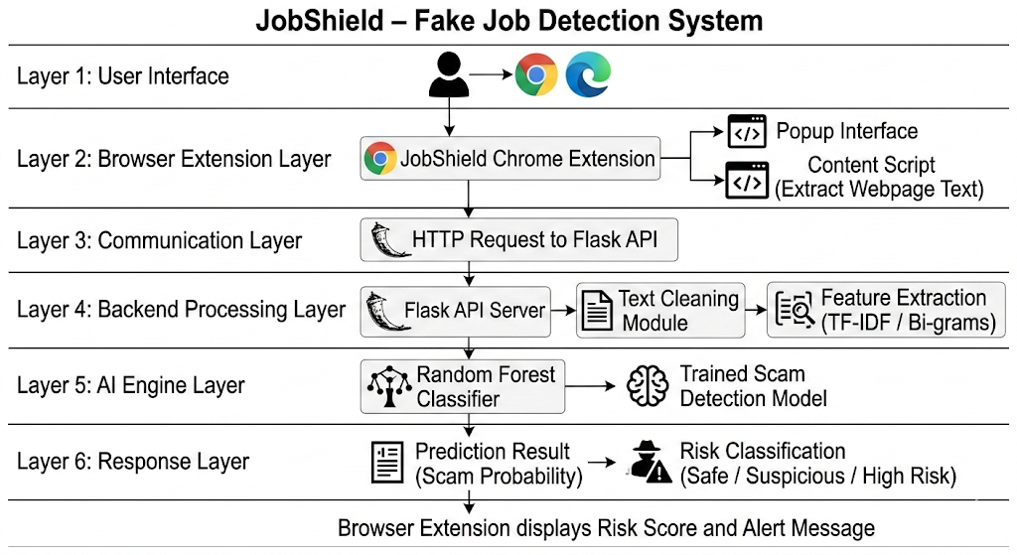
  - BLOCK DIAGRAM:
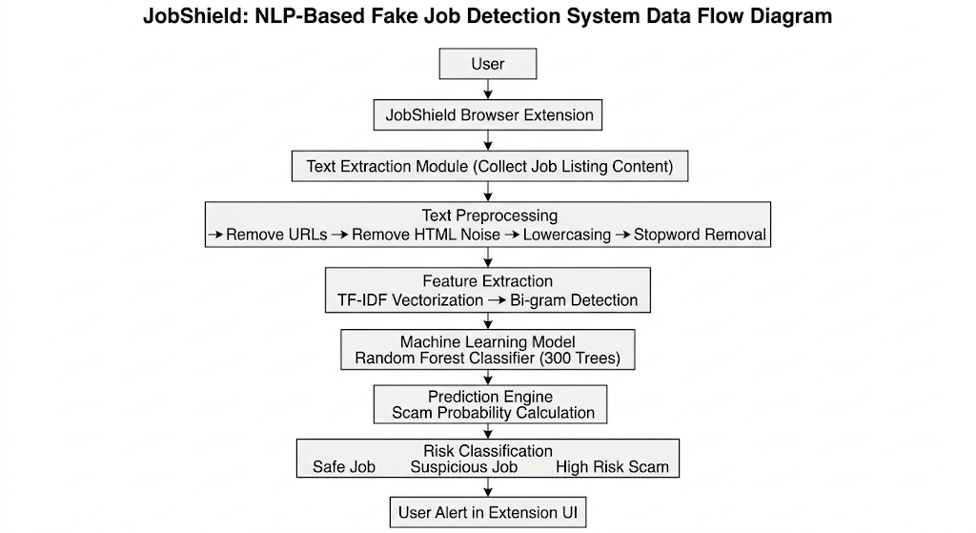
  - USE CASE DIAGRAM
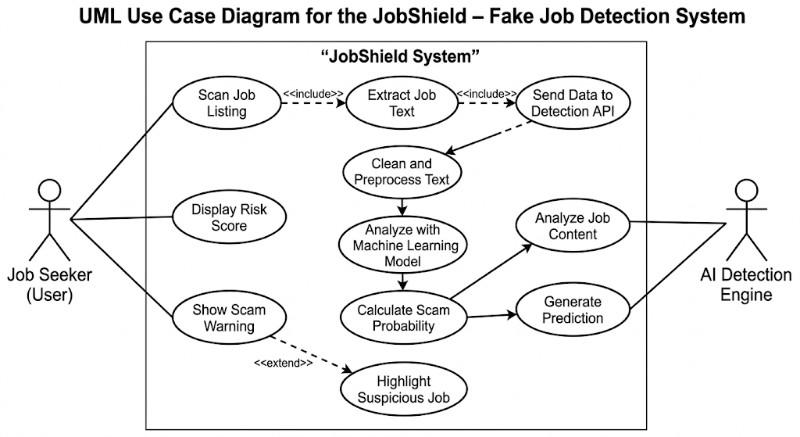
- SOFTWARE REQUIREMENT:
- Programming Language: Python
- Machine Learning & Natural Language Processing Libraries: Scikit-learn, NLTK
- Data Processing Libraries: Pandas, NumPy
- Visualization Tools: Matplotlib, Seaborn
- Feature Engineering & Text Processing: TF-IDF Vectorizer, N-gram (Bi-grams), Stopword Removal, Text Cleaning, Tokenization
- Backend Framework: Flask – used to create a REST API for real-time scam detection
- Browser Extension Technologies: JavaScript, HTML5, CSS3 – used for building the Chrome/Edge extension interface and browser interaction
- Development Environment: Visual Studio Code – for coding, debugging, and project development

- FUNCTIONAL REQUIREMENTS:
Objective 1: To develop an NLP-based machine learning model that analyzes job-related textual content and detects fraudulent job postings by identifying suspicious language patterns and scam indicators.
• The system should allow importing job posting datasets (CSV format) containing multiple attributes such as job title, company profile, job description, requirements, and fraud labels.
• The system should validate dataset integrity by checking for missing values, duplicate entries, and inconsistent textual fields.
• The system should perform text preprocessing including:
- Converting text to lowercase
- Removing URLs and HTML remnants
- Removing special characters and punctuation
- Removing stopwords
• The system should perform tokenization to break job descriptions into meaningful word tokens.
• The system should perform feature extraction using TF-IDF vectorization to convert textual job data into numerical feature vectors.
• The system should support bi-gram feature generation to capture contextual phrases such as:
- “registration fee”
- “urgent hiring”
- “work from home”
- “WhatsApp interview”
• The system should train a Random Forest classifier to learn patterns that distinguish legitimate job postings from fraudulent ones.
• The system should address dataset imbalance by balancing training data to improve detection of fraudulent job postings.
• The system should evaluate model performance using classification metrics including:
- Accuracy
- Precision
- Recall
- F1-score
• The system should save the trained machine learning model for later use in real-time prediction.

Objective 2: To implement a real-time browser-based detection tool that scans job listings and alerts users about potential recruitment scams using the trained NLP model.
• The system should provide a browser extension interface that allows users to scan job listings directly from web pages.
• The system should extract textual content from job listing webpages including job descriptions and requirements.
• The system should send the extracted text to a backend Flask API for scam detection.
• The system should perform real-time text cleaning and preprocessing before prediction to remove webpage noise such as HTML tags and embedded URLs.
• The system should convert the extracted text into numerical features using the trained TF-IDF vectorizer.
• The system should use the trained Random Forest classifier to predict whether a job listing is legitimate or fraudulent.
• The system should compute a scam probability score representing the likelihood of a job posting being fraudulent.
• The system should classify results into risk categories such as:
- Safe Job
- Suspicious Job
- High Risk Scam
• The system should display the prediction result within the browser extension using visual indicators such as:
- Risk score percentage
- Color-coded alerts (green, yellow, red)
• The system should allow users to perform one-click scanning of job listings directly from their browser.
• The system should provide a user-friendly interface with dynamic feedback to improve awareness of recruitment scams.
• The system should support continuous scanning of job content across different job portals and email platforms.

- NON-FUNCTIONAL REQUIREMENTS:
Objective 1: To develop an NLP-based machine learning model that analyzes job-related textual content and detects fraudulent job postings by identifying suspicious linguistic patterns and scam indicators.
- Accuracy: The system must ensure accurate detection of fraudulent job postings by correctly preprocessing textual data, generating reliable TF-IDF feature representations, and training the Random Forest classifier using balanced datasets to reduce bias.
- Scalability: The NLP pipeline should efficiently handle large volumes of job listings and textual data, allowing the model to scale for datasets containing tens of thousands of job descriptions without significant performance degradation.
- Performance: Text preprocessing, feature extraction, and model inference should execute efficiently using optimized libraries such as Pandas, NumPy, and Scikit-learn to ensure fast prediction time.
- Reliability: The system should consistently produce the same prediction results when the same trained model, preprocessing pipeline, and input job description are used.
- Robustness: The system should gracefully handle noisy text inputs such as incomplete job descriptions, HTML fragments, URLs, or unusual formatting without causing system crashes.
- Usability: The NLP model training pipeline should be modular, clearly documented, and easy to update (e.g., replacing the Random Forest classifier with other models such as Logistic Regression or transformer-based models).
- Data Integrity: The original job posting dataset should remain unchanged during preprocessing, and all transformations should be performed on processed copies of the dataset to prevent data corruption.
Objective 2: To implement a real-time browser-based detection tool that scans job listings and alerts users about potential recruitment scams using the trained NLP model.
- Accuracy: The browser extension should accurately display scam probability and risk classification based on predictions generated by the trained machine learning model.
- Scalability: The backend Flask API should support multiple prediction requests from the browser extension and allow the system to handle continuous scanning of job listings across different websites.
- Performance: Real-time prediction should occur within a few seconds so that users receive scam alerts instantly when scanning job listings.
- Robustness: The system should handle edge cases such as extremely long job descriptions, incomplete webpage text extraction, and unexpected webpage formatting without interrupting the extension functionality.
- Usability: The browser extension should provide a simple and intuitive user interface with clear risk indicators (safe, suspicious, high risk) and an easy-to-use one-click scanning feature.
- Security: Communication between the browser extension and the backend API should securely transmit job text data without exposing sensitive user information.
- Compatibility: The extension should function correctly across major Chromium-based browsers such as Google Chrome and Microsoft Edge.

- TEST CASE:
Test Case 1: Dataset Loading
Input:
User loads the fake job postings dataset (CSV file containing job listings with attributes such as title, description, requirements, company profile, and fraudulent label).
Expected Output:
Dataset loads successfully without errors; total row count, column names, and data types are displayed (e.g., “Loaded: 17,880 job postings, 18 attributes”).

Test Case 2: Data Cleaning & Validation
Input:
User executes the text preprocessing pipeline on the job posting dataset.
Expected Output:
• Text fields converted to lowercase
• URLs and HTML fragments removed
• Special characters and punctuation removed
• Missing textual fields handled using default values
• Summary report printed (e.g., “Text cleaned for 17,880 records”).

Test Case 3: Feature Engineering
Input:
User applies NLP feature extraction on cleaned job descriptions.
Expected Output:
Text features generated using TF-IDF vectorization and bi-grams.
Examples of generated features include:
• “registration fee”
• “urgent hiring”
• “work from home”
• “WhatsApp interview”
Feature matrix created successfully (e.g., “TF-IDF matrix created: 17,880 rows × 20,000 features”).

Test Case 4: Model Training
Input:
User trains the machine learning model using the processed dataset.
Expected Output:
Random Forest classifier is trained successfully.
Training summary printed including classification metrics:
• Accuracy
• Precision
• Recall
• F1-score
Example output:
“Model trained successfully with accuracy: 0.94”.

Test Case 5: Model Saving
Input:
User executes model saving step after training.
Expected Output:
Trained machine learning model and TF-IDF vectorizer are saved successfully as serialized files (e.g., “model.pkl” and “vectorizer.pkl”).

Test Case 6: API Prediction Request
Input:
Browser extension sends a job listing text to the Flask API /predict endpoint.
Example input text:
“Urgent hiring work from home job. No interview required. Pay registration fee to confirm your position.”
Expected Output:
API returns prediction result in JSON format including:
• Fraudulent label (0 or 1)
• Scam probability score
Example response:
{
"fraudulent": 1,
"scam_probability": 0.87
}

Test Case 7: Browser Extension Scan
Input:
User clicks “Scan Page” button in the JobShield browser extension while viewing a job listing.
Expected Output:
Extension extracts webpage text, sends it to the API, and displays the prediction result including:
• Scam probability score
• Risk classification (Safe / Suspicious / High Risk)
Example display:
“High Risk Job – Scam Probability: 0.87”.

Test Case 8: Real-Time Scam Detection
Input:
User scans multiple job listings across different websites such as job portals, email messages, or recruitment platforms.
Expected Output:
System performs real-time analysis of extracted text and provides instant alerts without browser crashes or significant delays.

- REFERENCES:
- Amaar, Aashir, Wajdi Aljedaani, Furqan Rustam, Saleem Ullah, Vaibhav Rupapara, and Stephanie Ludi. "Detection of fake job postings by utilizing machine learning and natural language processing approaches." Neural Processing Letters 54, no. 3 (2022): 2219-2247.
- Vidros, Sokratis, Constantinos Kolias, Georgios Kambourakis, and Leman Akoglu. "Automatic detection of online recruitment frauds: Characteristics, methods, and a public dataset." Future Internet 9, no. 1 (2017): 6.
- Vu, Dinh-Hong, Kien Nguyen, Khai Thien Tran, Bay Vo, and Tuong Le. "Improving fake job description detection using deep learning-based NLP techniques." Journal of Information and Telecommunication 9, no. 1 (2025): 113-125.
- Kumar, Shashikant, Sadiya Yasmeen, and Prabhat Kumar. "The Growing Threat of Fake Job Postings: A Review of Machine Learning and NLP-Based Detection Approaches." Revolutionary Advances in Computing and Electronics: An International Journal (2025): 41-51.
- Khandagale, Priya, Akshata Utekar, Anushka Dhonde, and S. S. Karve. "Fake Job Detection using Machine Learning." International Journal for Research in Applied Science & Engineering Technology (IJRASET) 10, no. 5 (2022): 1826.

